实验报告
学院（系）名称：计算机科学与工程学院
姓名 |  | 任毅 |  | 学号 | 20152178 |  | 专业 | 计算机科学与技术
班级 |  | 计算机一班 |  | 实验  项目 | 实验四：查询优化
课程名称 |  |  |  | 数据库系统 |  |  | 课程  代码 | 0668026
实验时间 |  |  |  | 2017.11.30 |  |  | 实验  地点 | 计算机软件实验室
考核标 准 | 实验过程  20分 |  | SQL语句正确性及运行情况 40分 | 实验报告质量(内容与格式) 30分 |  | 实验结果分析与特色创新10分 | 成绩
 |  |  |  |  |  |  | 教师签字：
考核内容 | 评价内容包括考勤与违纪、实验课上表现、编写程序过程、提问等 |  | 评价SQL语句的正确性及运行情况。每个语句4分 | ○完整  ○较完整  ○一般  ○内容极少  ○无报告 |  | ○有分析和创新  ○有分析或创新  ○无
一、实验目的
1. 了解数据库查询优化方法和查询计划的概念
2. 学会分析查询的代价，并通过建立索引或者修改SQL语句来降低查询代价
二、实验内容与要求
基于教材中的student、course、SC表，通过存储过程（要求在报告中写出存储过程），插入多条元组（1万条以上），考虑不同的SQL操作，分析比较执行代价。

1． 单表查询
（1）直接查询：查询student表中年龄在20岁以上的学生记录
代码：
dbcc dropcleanbuffers
dbcc freeproccache

set statistics io on
set statistics time on
go
select * from Student where Sage>=20;·
go
set statistics io off
set statistics time off
运行结果：
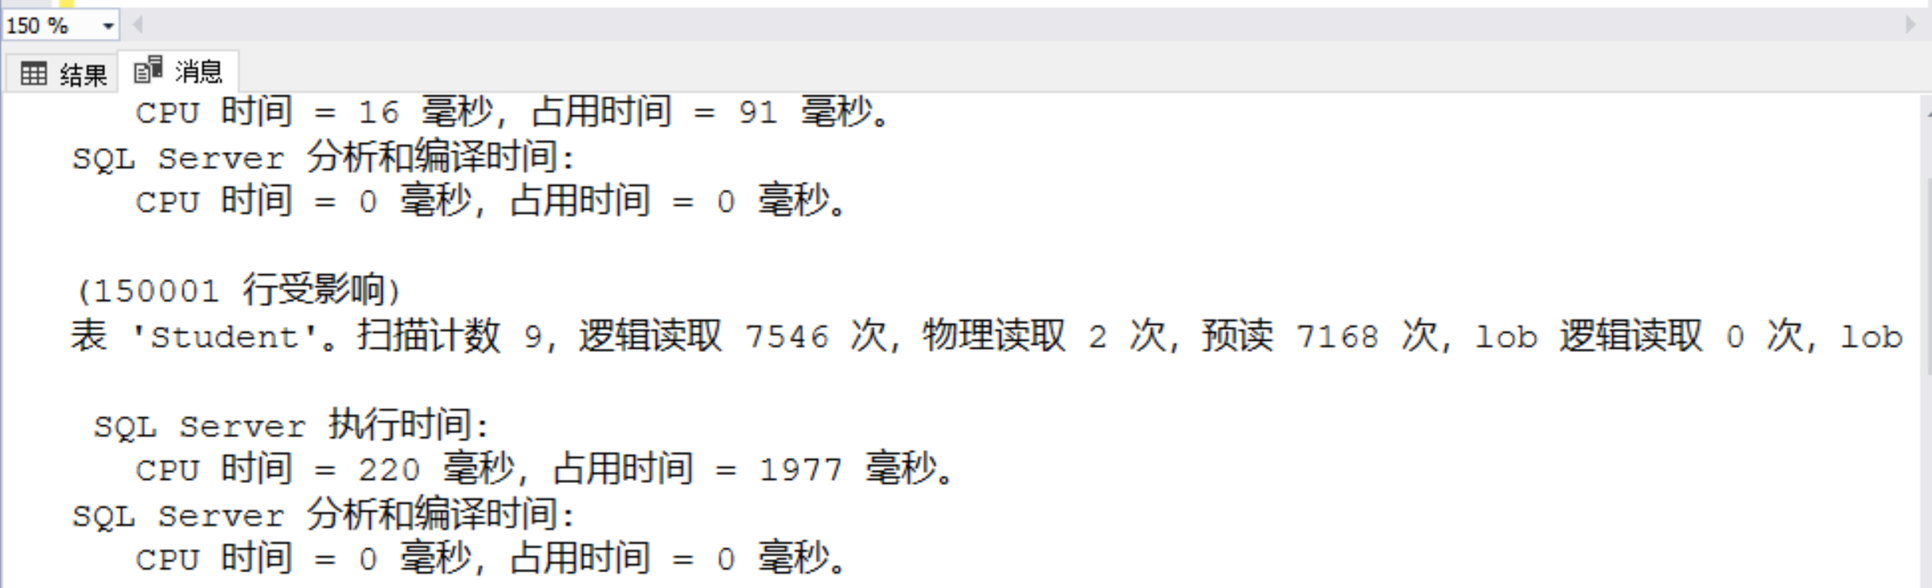

（2）建立索引后，再查询：查询student表中年龄在20岁以上的学生记录

代码：
create unique index Stusno on Student(sno);
dbcc dropcleanbuffers
dbcc freeproccache

set statistics io on
set statistics time on
go
select * from Student with(index(Stusno)) where Sage>=20;
go
set statistics io off
set statistics time off
运行结果：
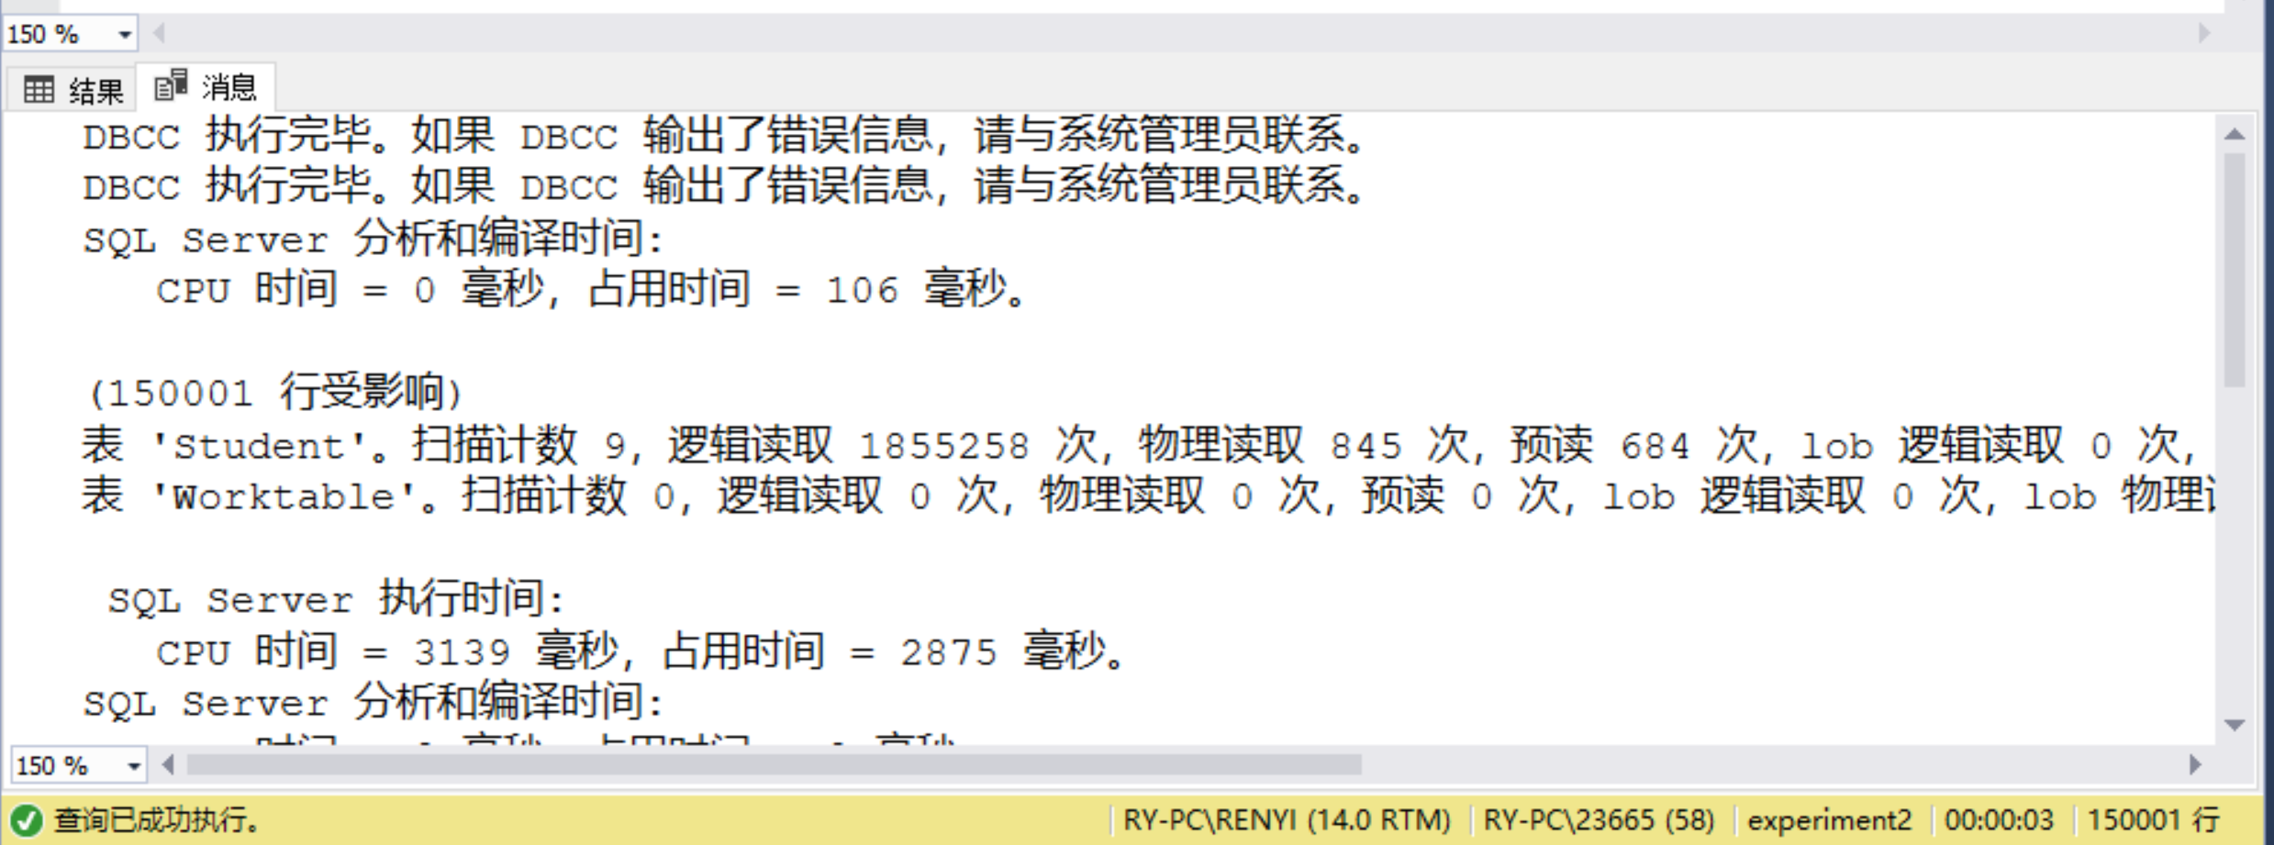

（3）表中元组数量少，查询结果所占比例大：查询student表中年龄在20岁以上的学生记录

为了实验方便在数据库中新建了一个新的表STU，并插入了1000条记录：

代码：
create table STU(
Sno char(10),
Sname char(10),
Ssex char(2),
Sage int,
Sdept char(10) );

create procedure insert_STUD
@sexflag int=0, @age int=0, @dept char(8)='MA',@i int=1
as
while @i<1000
begin
set @age = 20

if @i%4 = 1
set @age=18

if @i%4 = 2
set @age = 19

if @i%2 = 0
set @sexflag = 0
else
set @sexflag = 1

set @dept = 'MA'

if @i%3 = 0
set @dept = 'CS'
if @i%3 = 1
set @dept = 'IS'

insert into STU values(@i, 'Name'+cast(@i as char), @sexflag, @age, @dept)
set @i=@i+1
end

exec insert_STUD;

运行结果：
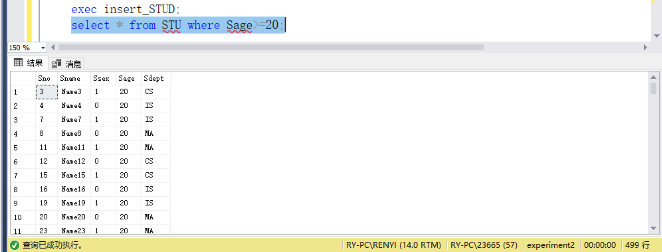

查询过程：
代码：
dbcc dropcleanbuffers
dbcc freeproccache

set statistics io on
set statistics time on
go
select * from STU where Sage>=20;
go
set statistics io off
set statistics time off
运行结果：
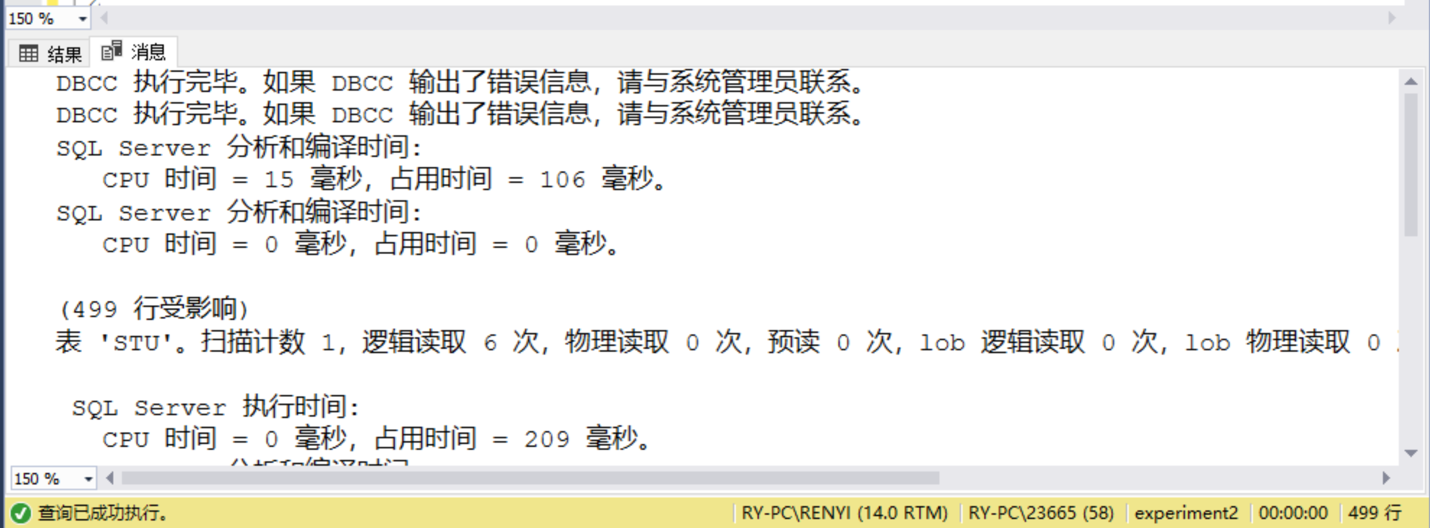
（4）表元组数量多，查询结果所占比例小：查询student表中年龄在20岁以上的学生记录

为了实验方便在表中插入100条年龄为21的记录，并改为查询年龄为21的学生记录

create procedure add2_Student
@sexflag int=0, @age int=0, @dept char(8)='MA',@i int=7000000
as
while @i<7000100
begin

set @age = 21
set @sexflag = 0
set @dept = 'MA'

insert into Student values(@i, 'add'+cast(@i as char), @sexflag, @age, @dept)
set @i=@i+1
end

exec add2_Student;
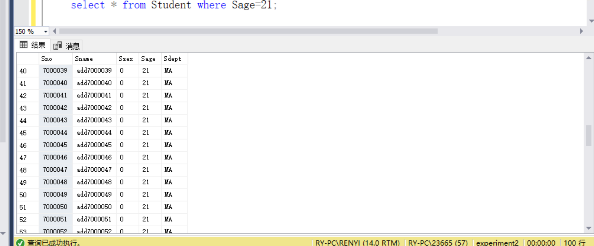

代码：
dbcc dropcleanbuffers
dbcc freeproccache

set statistics io on
set statistics time on
go
select * from Student where Sage=21;
go
set statistics io off
set statistics time off

运行结果：
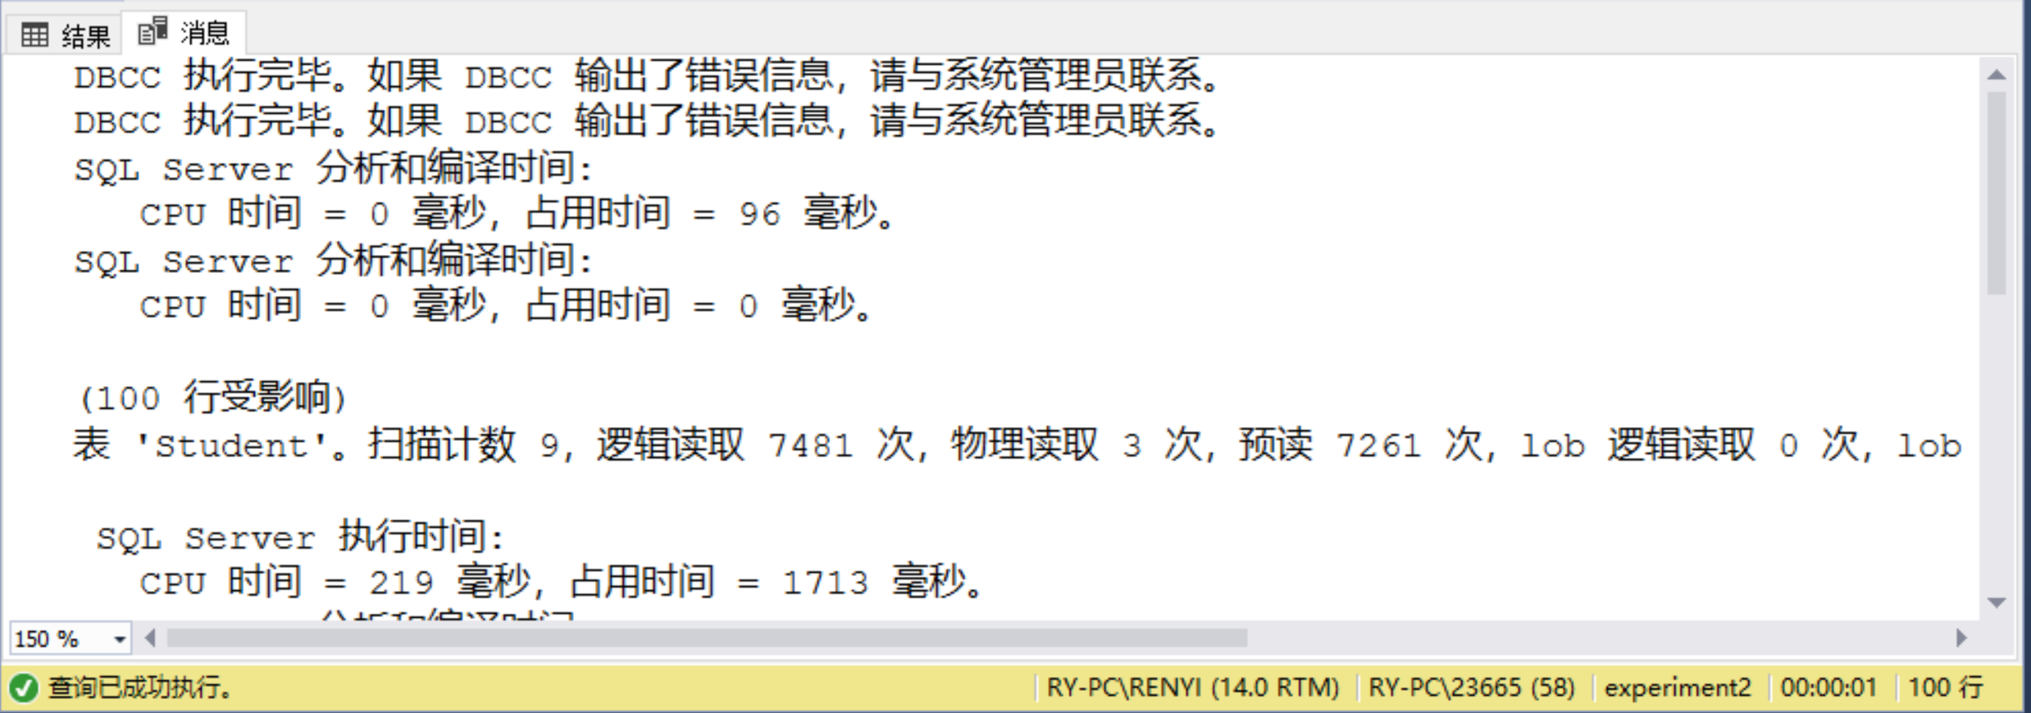

分析以上四种SQL查询的执行效率，并做总结：
查询方式没有绝对的优化，针对不同的数据库表效率不一。因此，需要对数据库的结构进行分析，才能制定出最佳的查询方式。

2.多表查询：基于student、course、SC表，按照以下要求，实现多表查询，并分析比较执行效率。（自行设计查询语句，要求针对同一查询内容，使用以下四种方式）

- 多表连接查询

代码：
dbcc dropcleanbuffers
dbcc freeproccache

set statistics io on
set statistics time on
go
select Student.Sno,Sname
from Student,SC,Course
where Student.Sno = SC.Sno and Course.Cno = SC.Cno and Cname = 'Course10'
go
set statistics io off
set statistics time off

运行结果：
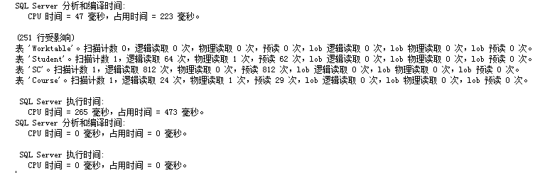

- 嵌套查询

代码：
dbcc dropcleanbuffers
dbcc freeproccache

set statistics io on
set statistics time on
go
select Sno,Sname
from Student
where Sno in(
select Sno from SC where Cno in (
select Cno from Course where Cname = 'Course10'
)
)
go
set statistics io off
set statistics time off

运行结果：
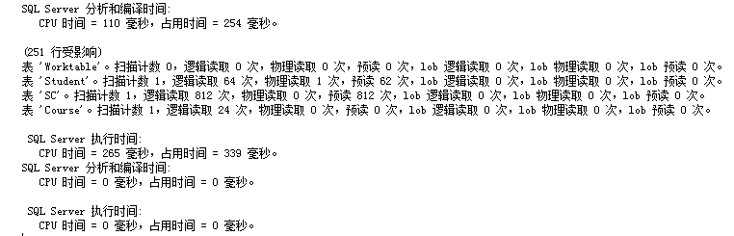

- 建立索引

连接代码：
dbcc dropcleanbuffers
dbcc freeproccache

set statistics io on
set statistics time on
go
create index index1 on Course(Cname)
select Student.Sno,Sname
from Student,SC,Course
where Student.Sno = SC.Sno and Course.Cno = SC.Cno and Cname = 'Course10'
go
set statistics io off
set statistics time off

运行结果：
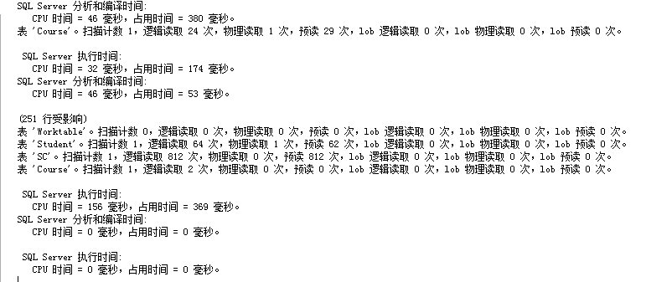

嵌套代码：
dbcc dropcleanbuffers
dbcc freeproccache

set statistics io on
set statistics time on
go
select Sno,Sname
from Student
where Sno in(
select Sno from SC where Cno in (
select Cno from Course where Cname = 'Course10'
)
)
go
set statistics io off
set statistics time off

运行结果：
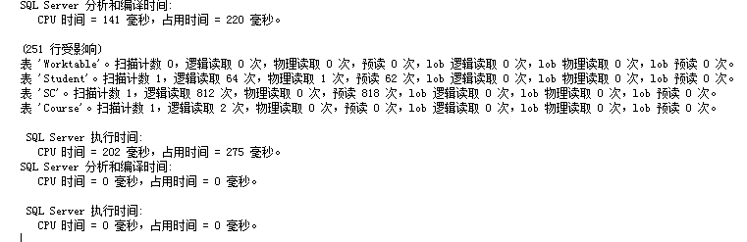

（4）使用游标

代码：
dbcc dropcleanbuffers
dbcc freeproccache

set statistics io on
set statistics time on
go
declare temp_cursor cursor scroll dynamic
for
select Sname from Student,Course,SC
where Student.Sno=SC.Sno and SC.Cno = Course.Cno
and Cname='structure'' and student.age <20
open my_cursor
declare @name sysname
fetch next from temp_cursor into @name
while(@@fetch_status=0)
begin
print @name
fetch next from temp_cursor into @name
end
close temp_cursor
deallocate temp_cursor
go
set statistics io off
set statistics time off
运行结果： 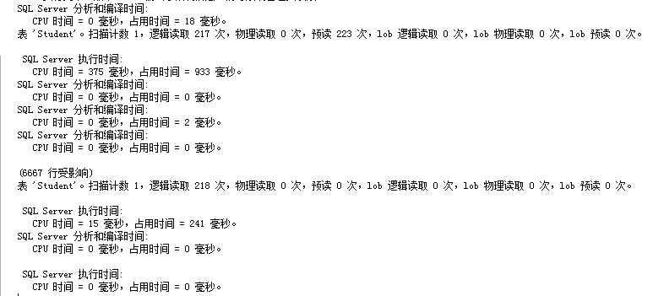
3．综合练习
(1) 对于student表，不按照姓名创建索引，查询某个姓名，所需要的时间。

代码：
dbcc dropcleanbuffers
dbcc freeproccache

set statistics io on
set statistics time on
go
select * from Student
where Sname = 'Name18478'
go
set statistics io off
set statistics time off

运行结果：
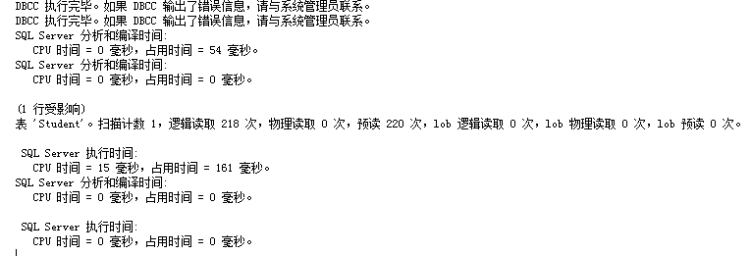
- 对于student表，按照姓名创建索引，查询某个姓名，所需要的时间。

代码：
dbcc dropcleanbuffers
dbcc freeproccache

set statistics io on
set statistics time on
go
create index Sname1 on Student(Sname)
select * from Student
where Sname = 'Name18478'
go
set statistics io off
set statistics time off

运行结果：
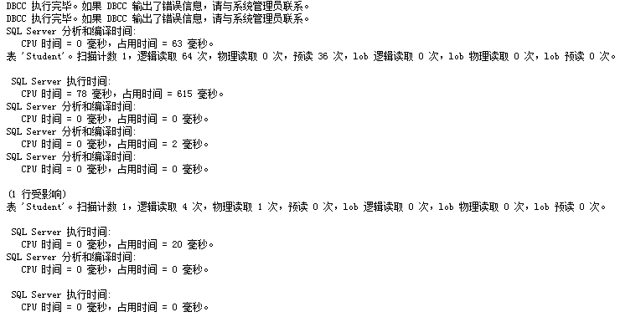
- 对于student表，不按照系别创建索引，查询某个系所有学生，所需要的时间。

代码：
dbcc dropcleanbuffers
dbcc freeproccache

set statistics io on
set statistics time on
go
select * from Student where Sdept = 'CS'
go
set statistics io off
set statistics time off

运行结果：
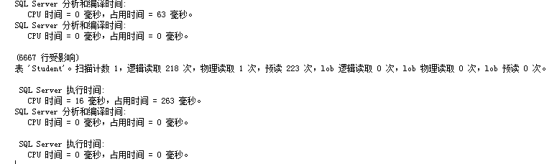

- 对于student表，按照系别创建各种索引，查询某个系所有学生，所需要的时间。

代码：
dbcc dropcleanbuffers
dbcc freeproccache

set statistics io on
set statistics time on
go
create index Sdept1 on Student(Sdept)
select * from Student where Sdept = 'CS'
go
set statistics io off
set statistics time off

运行结果：
- 查询sc表所需时间。

代码：
dbcc dropcleanbuffers
dbcc freeproccache

set statistics io on
set statistics time on
go
select * from SC
go
set statistics io off
set statistics time off

运行结果：
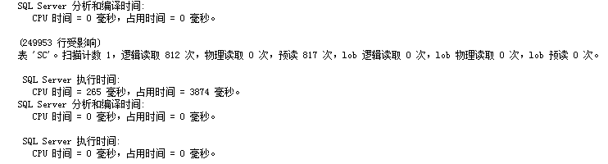
- 将student和sc连接所需时间。

代码：
dbcc dropcleanbuffers
dbcc freeproccache

set statistics io on
set statistics time on
go
select * from SC,Student where SC.Sno = Student.Sno
go
set statistics io off
set statistics time off

运行结果：
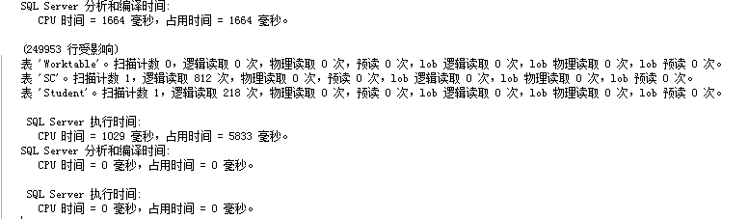
- 将student和sc和course连接所需时间。

代码：
dbcc dropcleanbuffers
dbcc freeproccache

set statistics io on
set statistics time on
go
select * from SC,Student,Course where SC.Sno = Student.Sno and SC.Cno = Course.Cno
go
set statistics io off
set statistics time off

运行结果：
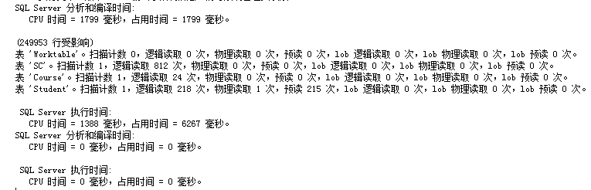
- 查询选修了“数据库”学生的学号姓名，分别用嵌套和连接的方法，观察两种方法所用的时间。

嵌套代码：
dbcc dropcleanbuffers
dbcc freeproccache

set statistics io on
set statistics time on
go
select Sno,Sname
from Student
where Sno in(
select Sno from SC where Cno in (
select Cno from Course where Cname = 'Course10'
)
)
go
set statistics io off
set statistics time off

运行结果：

连接代码：
dbcc dropcleanbuffers
dbcc freeproccache

set statistics io on
set statistics time on
go
select Student.Sno,Sname
from Student,SC,Course
where Student.Sno = SC.Sno and Course.Cno = SC.Cno and Cname = 'Course10'
go
set statistics io off
set statistics time off

运行结果：
4.实验要求：
1）在表中插入相应记录；
2）执行SQL语句；
3）认真完成并按时提交实验报告，在实验报告中附执行SQL语句、优化等分析比较截图；
4）整理上机步骤，总结经验和体会。

心得体会：
通过上机，对查询优化有了一个比较实际的清楚认识，明白了对于不同的数据结构，需要建立与之相对应的合理的差查询方式，才能最大的提高查询效率。没有完美的查询方式，只有分析数据库表的构成，才能找到合适的方案。

【实验过程记录（源程序、测试用例、测试结果及心得体会等）】

